2019
Presbyterian Times

From Our Pastor

Hope. Love. Joy. Peace.
These are the lights of the advent wreath that surround the Christ candle. We light them week by week as we go through the rituals which lead us to Christmas. For many of us this is a very busy time of year. It can get so busy that adding one more thing to the calendar can become overwhelming. Most of us spend too much money. We vow not to. We save up all year. But then those one or two extra items, the perfect gifts or the ones we forgot seem to stretch the budget more than we had hoped. Of course there’s travel for many. Family and friends to see. And while we complain that stores skip over Thanksgiving and jump right to Christmas, we would all be better off if we tried to spread Christmas cheer throughout the year, instead of all at once in 25 days.
At church we offer a little respite from the burdensome schedules, but we too add special events to the regular schedule. The cookie walk and bazaar is on December 7 Our Christmas Cantata is December 15 followed by the PW church wide holiday luncheon. On the afternoon and early of December 22 we will have an open house to which we will invite the community to come to the sanctuary to see the decorations, spend time in prayer, and take a break from the busyness of the season. We will offer some refreshments as well and end the evening with some Christmas carols. Of course we will have our Christmas Eve service at 5:30 on the 24th. At 7:00 pm on Christmas Eve, we are taking the opportunity to go to the Presbyterian Manor and offer an abbreviated service of lessons and carols for the residents.
As always, the season will be full, but I hope you find time to worship, pray, and prepare for the Christ child to be born. Let what you do help to share the light of the world and heal your grief, soothe your fears, and feed your spirit.
May you all know Christ’s hope, love, joy, and peace in the days to come.
Pastor Lou Ellen

Administrative Committee

Pledge cards: as we bring in the month of December and all the budget determinations are taking place our Treasure is asking that pledge cards be in by December 15th.
Thank you

Christmas time is the time to not only celebrate the birth of our Savior, but a time of gratitude for the gift of the Christ child. It is a wonderful time, when in the spirit of generosity, we can show our appreciation for others who daily share their talents with us. If you would like to show your gratitude for any or all of our staff, please feel free to present them with a card/or monetary gift, individually. If you prefer your gift to be anonymous, feel free to give your Christmas gift to one of our Administrative Committee members (Britt Whitaker, Ken Kwantes,
Marilyn Schmidt, Eleanor Van Horn, or Steve Zap) who will happily pass it on to the designated person.
What a delightful opportunity this is to show appreciation to our Pastor, our Office Manager, our Church custodians, our Nursery Attendant, our Accompanist, and our Music Director. Wishing for you a joyous Christmas, the Administrative Committee.

Mission Committee News
Greetings from the Worship and Music Committee, it is with great joy that we begin our preparations for Advent. We will be hanging the greens, decorating the tree and changing the Paraments in the Sanctuary. All this to provide a warm and welcoming worship space as we celebrate the coming of our Lord.
Sunday, December 15 the choir will be sharing The Christmas Cantata with us during our regular worship service. The Cantata is always, a very enjoyable and inspiring experience. Please feel free to invite guests to join us.
The Worship Committee and the Congregational Life Committee together will be hosting a “Christmas Open House” Sunday, December 22. We will be welcoming visitors into the Sanctuary from 3:00—5:00 in the evening. Snacks and cookies will be provided. Also, we will finish our get together with a traditional Christmas Carol sing along.
Our Christmas Eve service will begin at 5:30 pm.
We wish you all a very merry Christmas.

Memorial Garden
During the next couple of months, if you wish, you may place an order for a Memorial Brick in memory of a church member, friend, or family member.

The cost of the brick is $100.00, part of which pays for maintenance of the Garden.
Please contact Marilyn Schmidt if you wish to purchase a brick.

Congregational Life Committee
Would like to wish everyone a Merry Christmas
and Happy New Year.
Cookie Walk and Bazaar
Countdown to Saturday, December 7th Cookie Walk and Bazaar. A quote from our Neighbor Baker, Ms. Marilyn “The more you bake, the more we make”. You may bring your cookies and baked goods to the Fellowship Hall on Friday, the 6th from 9 to noon. The Sale will begin at 8 on Saturday, lasting until 2. Please sign up if you can work on Saturday. Thank you in advance for your baking and buying. Proceeds go to local missions.
Preschool News
November brought us many things to be thankful for; our time together, the new friends we have made, the learning that takes place and so much more. We are also thankful for the several new families who joined us during the month. We celebrated of friendship with a Fruit Feast. Every child brought in fruit and we made a fruit salad that all enjoyed.
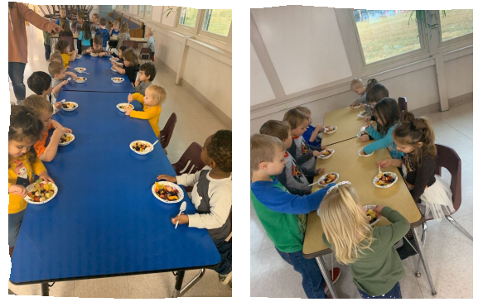
We will be having a Christmas Program December 16th at 6:30.

Preschool Director
Tracy James
From the Office
Katie Sands Office Manager

Merry Christmas to you all, have a safe and Happy New Year.

Birthday wishes for December go out to:
1st John Denbo
3rd Brett Hartley
5th Paden Long
6th Bill Morgan
8th Caleb Rose, Dace Murray
9th Michael Bennett
15th Bill Winch
17th Glenda Knight
26th Caitlin Bennett
27th Barbara Ford

Anniversary wishes for December go out to:

17th Jim Drewniak
& Mariesa Drewniak

December 24th Office hours are 8:00a.m. – 12:00p.m.
December 25th Office will be closed. We will reopen on Wed. 26th at 8:00 a.m.

Kimball’s Address Change
Jonathan, Rhonda, Sam, and Jesse Kimball
601 Southview Dr.
Rolla, MO 65401

Please pray for: David Winch(seizure disorder)Pourya Shamsi (Jonathan’s colleague diagnosed with lymphoma) Lee Bennett (Hip surgery) Bill Crawford (stents placed, ICU now) Carla Simmons (shingles) Lexi Francis (Lorie’s daughter in law, having brain surgery) Kelly Look (Retina Surgery) Bob Anderson (heart issues) Corbin Capps (Tracy’s new grandson/ health issues) Amy Whitaker (cancer diagnoses) Connie DeWitt (continued health issues) Mary Jane Potrafka (ongoing health issues) Betty Lemp, Kathleen Dean (ongoing respiratory issues).

The prayer request list will start over about every two months. If you have someone who needs put on or taken off the list, please contact Katie in the office

First Presbyterian Church
919 E. Tenth
Rolla, MO 65401
Telephone: 573-364-3852 / Fax: 573-426-5320

