This Photo by Unknown Author is licensed under CC BY-ND
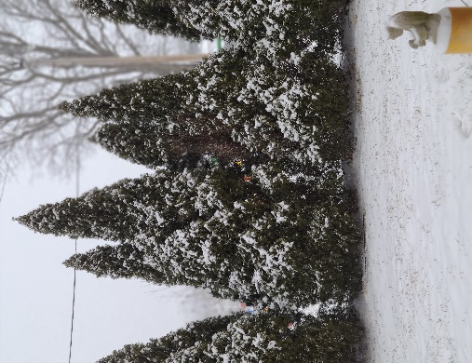
(Memorial Garden 01-27-2021)

Presbyterian Times
February 2021

First Presbyterian Church
919 E. Tenth Street Rolla, MO 65401
Telephone: 573-364-3852 / Fax: 573-426-5320
Email: office@rollapresby.org

A Message from Our Pastor
Rev. Lou Ellen Hartley

I hope this newsletter finds all of you well. As you receive this letter, we are preparing to enter the Lenten season of 2021. I know that a year ago, we could not imagine the changes we have gone through, the adjustments, we have all made in the last 11 months. As I write this letter we are looking once again spending this season worshiping remotely. The Session met and determined that with the trends in spread of the corona virus, we will continue to worship remotely until at least June 6. As vaccinations increase, we will continue to watch the infection rates in our area as we determine when best to reopen for in person worship. With that in mind, we will be attempting to enhance our remote worship in a variety of ways.
We will post a daily devotional guide from Presbyterian Outlook. This year the study will focus on prayer. As part of this study, we invite you to email or mail prayers for peace and hope for yourselves, for our community, and for the world. We will take your prayers and put them on strips of cloth which we will hang from one of our trees in the church yard. We hope that by the end of Lent when Easter arrives, we will have a tree covered in prayers. As the weather changes and we are able to spend time outside, we will plan opportunities to meet safely.
We will have an Ash Wednesday Zoom Service at 6:30 pm February 17. Throughout the Lenten season we will have Zoom prayer meetings at noon on Wednesdays.
I know we need each other, social interaction, being close to friends and those we love. We will work hard to make sure we are connected. I realize there is nothing we can do that will replace in person activities, but we will do our best here at the church to provide opportunities for worship, connection, and ministry.
Peace and comfort to you all,
Pastor Lou Ellen

DO YOU NEED HELP FIGURING OUT HOW TO GET YOUR COVID VACCINE?
As with many things in 2021, the way to sign up for the COVID-19 vaccine is generally through the internet. If you would like help signing up, please contact Britt or Amy Whitaker or another elder. We are here to help you!

INSTALLATION of CHURCH OFFICERS
We will be installing our church officers via zoom at our next Session meeting on February 15. When we are able to worship in person again, we will celebrate our officers and recognize their commitment.

SPECIAL MISSION OFFERING FOR G.R.A.C.E
Once again, John Calvin Presbytery is inviting congregations to apply for COVID-19 grants. The presbytery is providing these grants to help ministries which serve those particularly impacted by the pandemic. The presbytery will match our offerings up to $2500. Over the next four weeks we will collect a special offering for GRACE and then apply for the presbytery grant. If you would like to give to this offering, please indicate it on your check’s memo line. Thank you!

LINEN CLOSET

Thank you from the Linen Closet. What a nice assortment of blankets and pillows, I just put away in the closet. Thank you all, our clients will sleep warm and snuggly.
Melba

Per Capita for 2021 will be $38.50.

Preschool News
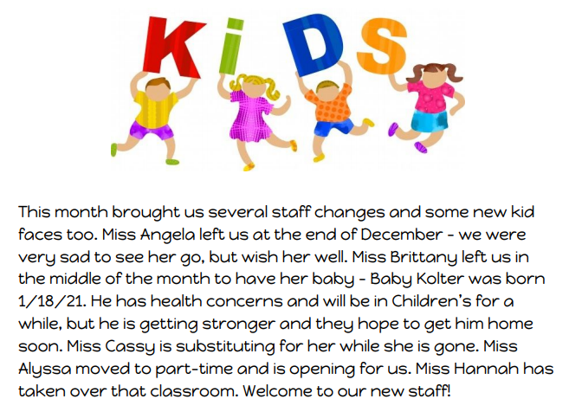
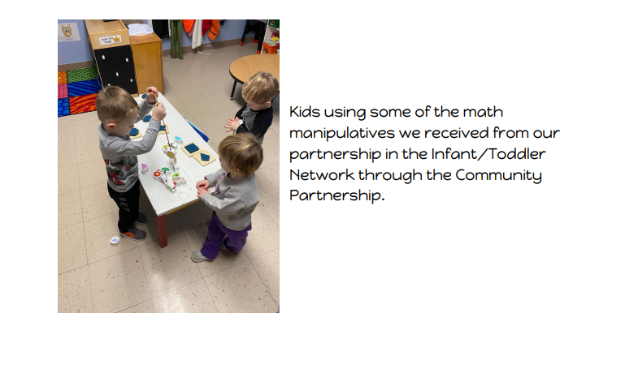

FROM THE OFFICE
Katie Sands, Office Manager

Happy Birthday wishes for our February birthdays!
This Photo by Unknown Author is licensed under CC BY-NC

Happy Anniversary wishes to our February Couples!
This Photo by Unknown Author is licensed under CC BY-SA-NC

Please keep in mind and prayer those friends isolated because of the Virus.

